This report details the procedure for simulating an Ising model on a finite piece of a honeycomb lattice, using the Monte Carlo method. The question posed is:

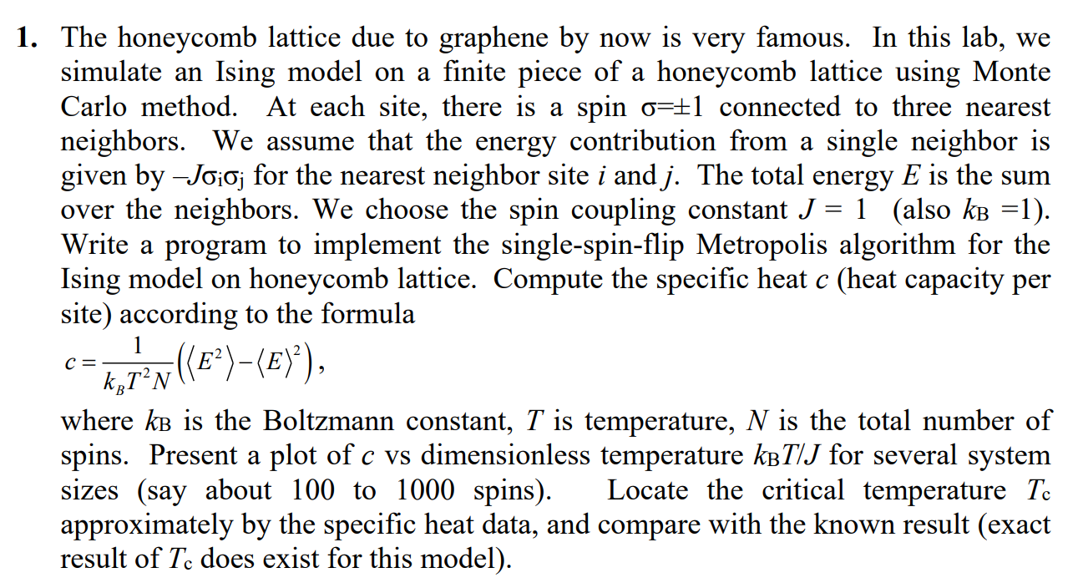

To tackle this problem, a matrix representing the lattice must first be constructed. The honeycomb lattice in question is the structure of graphite, whereby each atom in the lattice has three neighbours. Considering the unit cell of the lattice, we find that each unit cell has only two atoms in it, with each unit cell occupying a unique (x,y) coordinate. Hence, the matrix is configured to be three-dimensional, whereby the first two dimensions specify the 2D coordinates of the unit cell and the third specifies whether it is the top or bottom atom in the unit cell. The value of the matrix at any location is the current spin state at that position.

Given a temperature, we use the Ising model to obtain the final spin states of the honeycomb lattice, using the Monte Carlo and Metropolis algorithms. Monte Carlo methods are a broad class of algorithms that employ statistics to obtain approximate results, as opposed to exact ones. The main advantage of this is that sufficiently accurate results can be obtained quickly, without requiring much computational power. The downside is, of course, the error incurred, as many iterations have to be carried out to approach the exact result, and statistical testing has to be performed to ensure that the approximate solution of sufficient accuracy.

The Ising model involves altering the spin state of a randomly chosen site, in a way that seeks to reduce the overall Hamiltonian, or energy, of the lattice configuration. 3 random numbers are chosen to locate a particular site. At the site, the Hamiltonians are calculated before and after the spin is flipped (**Hold** and **Hnew** respectively), where it is calculated by E = -J * sum of the product of the spin states of the site and its immediate neighbours. If the new energy is less then the old one, the new configuration is accepted. Otherwise, the new configuration is accepted with a exponential probability involving the difference in **Hold** and **Hnew**, constant K and temperature. This is to ensure that detailed balance is maintained.

To ensure a fairly accurate result, a convergence criteria was implemented, where If the total energy of the lattice has decreased by less than 0.00000001 after every 2*n^2 cycles (n*n being the lattice size), then the simulation stops and the results are printed. Attached below is the graph obtained:

From the graph, we can observe that the lattice is configured to start out with a total spin of 1. As the temperature is increased, the beta is increased and as mentioned above, the probability to flipping the spins is increased. As the temperature increases beyond a certain point, it appears to fall markedly, after having been almost constant. This is the phase transition predicted by the Ising model, the simplest one to do so, whereby a total spin of 0 is favoured after a certain temperature point.

This is the plot of the dimensionless energy of the system against the temperature-dependent constant. It can be noted that the energy of the lattice increases as the temperature increases.

This plot is clipped as the calculated heat capacity when the temperature-dependent constant is near 1 is too large to accurately show the small values outside of the neighbourhood of 1. This indicated that the phase transition occurs when the temperature dependent constant is near 1, which is corroborated by the first plot as well.